Reflection on Our Interview with Engr. Christian Jay Cuevas

Barizo, Julian Benedict
Bautista, Mark Joneil
Carcellar, James Earl
Esteta, Jesse Matthew
Geronimo, Joncel

Technological Institute of the Philippines
Computer Engineering as Discipline
CPE11S2
November 2025

2. Introduction (1 paragraph)
As part of our requirement to learn from the experiences of Computer Engineering graduates, I interviewed Engr. Christian Jay Cuevas, a distinguished BS Computer Engineering alumnus whose main track was Intelligent Systems. He is currently working as an AI Engineer at Offshore Leak and has notable achievements such as being a Cisco Netrider Awardee and a DOST scholar. During his college years, he also worked as a freelancer, developing thesis systems for various schools and handling 3D-printing projects. The interview focused on his academic journey, thesis work on a stray animal management system, professional experiences, and the insights and advice he shared for aspiring Computer Engineers.

3. Summary of the Interview (1–2 paragraphs)
During the interview, Engr. Christian Jay Cuevas shared meaningful insights about how the Computer Engineering curriculum shaped his career and professional mindset. He explained that the program prepared him mentally and built strong foundational knowledge in areas such as data algorithms, data science, and embedded systems. He emphasized, however, that self-study played a major role in his development, especially because frameworks used in web and mobile development were not taught during his time. He also highlighted the importance of cooperation and leadership skills, which he developed through thesis work and competitions, particularly because working with randomly assigned groupmates required adaptability and self-awareness.

Engr. Cuevas also discussed the specific skills that proved most beneficial in his career as an AI Engineer. Although his track focused on Intelligent Systems and hardware, he shared that his greatest regret was not pursuing data science earlier. Courses like Emerging Technologies, which introduced fundamental data science concepts and Python programming, became the most useful in both his internships and job. Regarding his professional challenges, he explained that a major task in his work involves improving efficiency for users by creating AI systems that streamline processes. Thesis preparation and courses such as Software Life Cycle equipped him with important skills in user-centered thinking, software deployment, and agile methodologies.

He also reflected on lessons learned the hard way, sharing that failing to meet panel expectations during his 4th-year thesis taught him the importance of thinking ahead and anticipating feedback. He emphasized that students should not be overly focused on grades, as employers value skills, experience, and projects more. His advice to current students included joining competitions, attending seminars, earning certificates, learning development frameworks, and choosing tracks and professors wisely. He encouraged students to enjoy the course, engage in school events, and build strong connections with faculty to maximize the benefits of the program.

4. Personal Reflection (2–3 paragraphs)

Julian’s Reflection:
What struck me the most from the interview was how vast the field of technology truly is. Listening to Engr. Cuevas made me realize that, as a first-year student, I have only encountered the surface of what Computer Engineering has to offer. There are countless areas to explore like data science, software development, hardware systems, artificial intelligence, and so many other niches that each require depth and dedication. His experiences made me aware of how much learning still awaits me and how many possible career paths I may pursue in the future. It was both overwhelming and inspiring to see how wide the field is compared to my current understanding.
His story also deeply influenced the way I view my academic and career goals. Before this interview, I believed that maintaining high grades was the top priority in college. However, his perspective made me realize that real growth comes from experiences, challenges, and the projects you pursue, not just numbers on a grade sheet. This shifted my mindset about what truly matters in my journey. Hearing about the seriousness of the thesis, the pressure of defenses, and the expectations of panelists also made me understand the importance of preparation, teamwork, and foresight as I progress through the program. It showed me that Computer Engineering will demand much from me, but it will also build me in ways that matter for the future.
One of the most surprising and inspiring moments was when he shared that he often received passing grades and even failed a thesis requirement due to missed deadlines. Yet despite these setbacks, he still succeeded, earning certifications, gaining confidence, joining competitions, freelancing, and eventually landing a job not because of perfect grades but because of his skills and accomplishments. This reminded me that failure does not define one’s future but perseverance and continuous learning do. It was motivating to see proof that resilience can bring someone far in this field.
From this interview, I plan to apply many of the lessons and advice he shared. I hope to participate in competitions, attend seminars, and earn certifications that can strengthen my skills and broaden my opportunities. I also want to start learning frameworks early, explore fields such as data science, and choose a track that aligns with future industry demands. Most importantly, I will try to enjoy the journey and try to engage with professors, join events, step out of my comfort zone, and embrace both challenges and failures as part of my growth in Computer Engineering.
Mark’s Reflection:
I found his perspective on thesis work and strict professors meaningful. Instead of viewing thesis as just another academic requirement, I now see it as mental training an opportunity to build discipline, problem-solving skills, and user-focused thinking. His advice to seek challenging mentors rather than easy grades is a reminder that growth often comes from discomfort. Likewise, his point about aligning electives with career goals instead of convenience pushes me to be more intentional with the choices I make.

James’ Reflection:
Looking back from the interview, I see that Engr. Cuevas’s had a strong passion for data science. He repeatedly emphasized its potential, its growing importance, and its high demand in the job market. The way he talked about it felt genuinely persuasive, as if he truly wanted us to recognize the opportunities it can open. On top of that, I was also surprised by his achievements, they were remarkable, he must truly enjoy his time as being a computer engineering student. However, challenges shape him to improve himself more, especially hearing about the challenges he faced, especially in his thesis, made me realize that even skilled engineers encounter difficulties, not just in technical or math-heavy courses but also in major projects that require teamwork collaboration and persistence.
With his story, it greatly influenced how I view my own academic and career goals. It made me seriously consider exploring data science, and interestingly, I have already started learning it. I’m becoming more curious about Python and want to build simple projects to improve my skills and strengthen my profile. His journey showed me that learning beyond the classroom can offer things that you will be grateful for in the future.
Among the many lessons he shared, the advices that stayed with me the most were, first to always think ahead, predict what others might think or expect so you can prepare better. He also encouraged us to study in advance and pursue self-learning, especially in fast-evolving fields like data science. Lastly, I strongly agreed when he said that grades do not matter as much as outside the curriculum and the skills you’ve gained. Additionally, this inspired me to consider joining hackathons and competitions to gain real-world experience and challenge myself beyond academics. In the college life of Computer Engineering, exploring the vast seas requires having the right tools with you. These tools will help you go far and reach the things you truly want, whether consciously or unconsciously.

Jesse’s Reflection:
In the interview, Engr. Cuevas discussed how his years in Computer Engineering prepared him mentally and helped him build strong foundations for his specialization. He mentioned that the program introduced important frameworks but did not go deeply into them, which pushed him to rely on self-study, especially for thesis work. He also shared how leadership and communication skills became essential since thesis groupings were random, teaching him how to work with different people. Engr. Cuevas talked about his regret in not choosing the data science track, explaining that it would have aligned better with his current role as an AI engineer and provided more opportunities compared to hardware-focused subjects. He further emphasized how thesis, the software life cycle lessons, thinking ahead of panel expectations, joining competitions, attending seminars, earning certifications, and choosing professors who challenge you all contributed to his growth and readiness for the industry.

Among the many lessons he shared, the advice that stayed with me the most was to always think ahead and try to predict what others might expect so I can prepare better. He also encouraged us to study in advance and commit to self-learning, especially in fast-evolving fields like data science. I strongly agreed when he said that grades matter less compared to the actual skills and experiences one gains outside the curriculum. His words inspired me to consider joining competitions, and other activities that can help me grow beyond academics. In Computer Engineering, having the right skills, habits, and mindset equips you to reach your goals and make the most of every opportunity.

Joncel’s Reflection:

The interview really opened my eyes to what it’s actually like to work in the tech industry. What stood out the most was how Sir Christian said that school only teaches the basics, and the rest is really up to you. Hearing about how much he learned through self-study, competitions, and real projects made me realize how important it is to explore things outside the classroom. I was also surprised when he shared how he struggled during thesis, even getting low grades after years of doing so well. Instead of giving up, he pushed through and still became successful. That really inspired me, because it showed me that grades don’t define everything. What matters is experience, effort, and not giving up when things get hard.

His story also changed how I see my own future. It made me want to focus more on building skills that will actually help me in the industry, like learning frameworks and exploring data science early on. I might also want to join competitions, attend seminars, and grab opportunities that can help me grow. The biggest lesson I took from him is to think ahead and to never rely only on what is taught in class. I learned that I need to be flexible, work with different people, and keep improving myself.

5. Connection to Course or Program (1 paragraph)
The interview with Engr. Cuevas greatly established the relevance of the concepts and foundations we are going to learn in the Computer Engineering Program. Many of the topics he mentioned like data science, algorithms, embedded systems, are all courses that form the core of the curriculum. Hearing how these fundamentals helped him in real industry situations greatly improved my understanding of why these courses matter. His emphasis on self studying, learning frameworks, and exploring fields like data science and such highlighted how the CpE program is not limited to what is only being taught in class rather it is encouraged that they expand their knowledge beyond the curriculum.

6. Conclusion (1 paragraph)
To conclude, our interview with Engr. Christian Jay Cuevas felt like a meaningful conversation that gave us a clear depiction of what Computer Engineering really looks like in the real world and in the industry. Listening to his stories about his experiences, struggles, achievements, and the choices he made helped us understand that this course is more than just aiming for high grades. It is about building skills, gaining experience, and discovering which part of the huge world of technology you want to grow in. The way he talked about the challenges he faced, especially the time he fell behind or made mistakes, made his success even more inspiring because it really showed us that progress matters more than being perfect. This interview also made us reflect on our direction and where we’re going as future Computer Engineers. We realized that there is so much we can explore and prepare for while we are still students, whether it is improving our coding, trying new technologies, and taking on projects that interest us. Most of all, we are grateful for all the advices and insights he shared. Everything we learned from him will surely guide us as we continue our journey in this course.

7. Appendices
- Photo with the alumnus/alumna
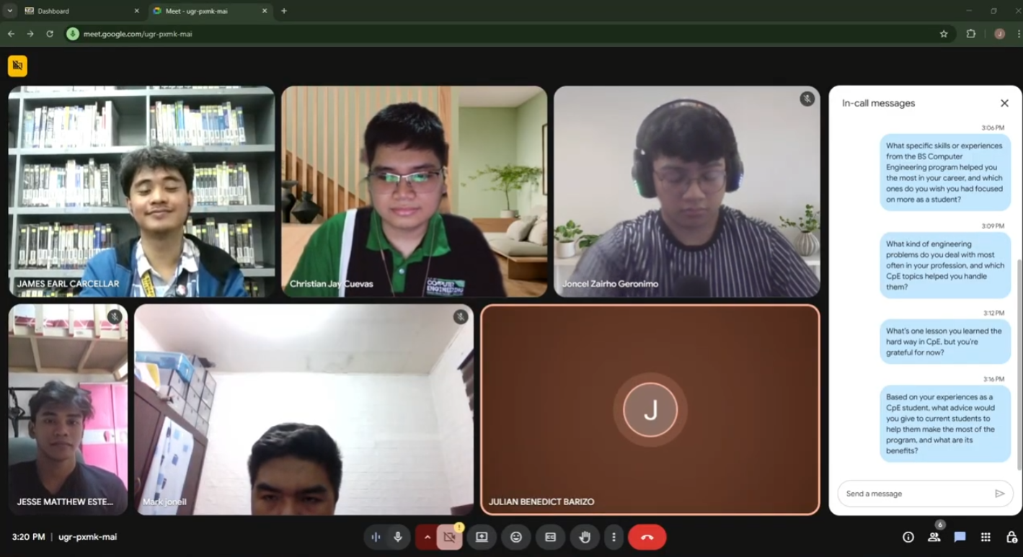
(Julian Benedict Barizo’s camera was malfunctioning here so they weren’t able to turn on their camera)

